# Media Analysis - AI is not smarter than humans

## Short Summary

": "The article critically examines the reliability of AI following Microsoft's chatbot Tay's racist behavior due to user inputs, stressing the necessity for responsible AI development and use, while acknowledging potential benefits but emphasizing that AI lacks human understanding, especially cultural nuances, potentially undermining essential human connections."  
}

## Summary

1. **AI Tools as Companions**: The article highlights how AI tools, including chatbots like Tay by Microsoft, have become valuable companions in personal tasks and business operations. These tools can perform functions such as reminding users of pending duties, setting alarms, providing information, and even generating marketing campaign ideas.  
  
2. **Advancements in Natural Language Processing**: The author points out the significant progress made in natural language processing technology, enabling AI to understand human language better. Tools like Siri from Apple demonstrate this capability, offering more than just simple yes/no answers and assisting with complex tasks such as brainstorming ideas for letters or resumes.  
  
3. **Overcoming Language Barriers**: The author notes the advancements in cross-lingual AI capabilities, which have made it possible to use technology across different languages, fostering global communication. For instance, Google Translate has helped bridge language gaps between tech-savvy young individuals and elderly friends like Saleh who were unfamiliar with such tools.  
  
4. **AI's Limitations in Understanding Culture**: Despite the advancements, AI struggles to fully comprehend cultural nuances. The author uses an example of Flag Day celebrations to illustrate this point - AI may be able to predict marketing ideas but cannot capture the emotional and meaningful aspects associated with such events.  
  
5. **AI's Role in Business and Marketing**: The article suggests that AI plays a crucial role in simplifying business operations, market analysis, and even generating creative content. However, it acknowledges that AI lacks human qualities like empathy or personal experiences which are integral to certain aspects of these fields.  
  
6. **Preserving Human Connection**: The author underscores the importance of human connection amidst technological advancements. AI can support and enhance communication but cannot fully replace the unique, personal touch that humans bring in their interactions with others.  
  
7. **Future Prospects of AI**: Despite concerns about reliability and understanding human nuances, the author remains optimistic about AI's potential to revolutionize various aspects of life. As technology evolves, AI will likely continue to provide valuable assistance while maintaining its complementary role alongside humans in society.

## Question 1:

How do the media in this article frame the public discussion about ChatGPT? Are there certain **metaphors** that keep cropping up?

The media in this article frames the public discussion about ChatGPT by positioning it as an assistant or helper (similar to setting alarms with Siri), a powerful force for change in business contexts (like using AI to revolutionize various aspects of life), and cautions against over-reliance on AI through examples like Tay's problematic behavior. The metaphor of ChatGPT understanding human culture and emotions remains central, raising concerns that while it can be a useful tool, it may struggle to replicate the depth and nuance of genuine human connections.

## Question 2:

Which role does or might the Arabic World play in the development of Artificial Intelligence? Answer with 'Not mentioned' if not applicable.

Not mentioned

## Question 3:

Which use cases of Artificial Intelligence are helpful for the Arabic world based on this article?

Virtual assistants (Siri), chatbots capable of engaging in business-related conversations, and virtual assistants aiding personal communication and creativity.

## Question 4:

What is the final message of the article that the author wants to convey? Keep your answer short and precise!

Despite the progress and potential of AI, the author stresses that it will never fully replicate the richness and depth of human connection. AI can assist us, but it cannot replace our unique ability to understand, communicate, and nurture meaningful relationships.

## Sentiment

The sentiment is <4>

The author presents AI as an incredible tool that enhances personal life and business tasks, highlighting its usefulness while acknowledging limitations such as its potential to be corrupted or lack cultural understanding. The author emphasizes the importance of human connection over technology, suggesting that AI can supplement but not replace human interaction.

## Entities

Kid Singe, Real Life Recruiter Marketer, National Anthem Look Flag, Grace Business Operation Marketing Department Include Computer Understand Like Culture, Offer Simple, Ai Smart

## Topic Clusters

### Cluster: AI Capabilities

ChatGPT, Advancements in AI

### Cluster: Limitations

ChatGPT's performance, Ethical concerns

## Word Clouds

### Wordcloud of content

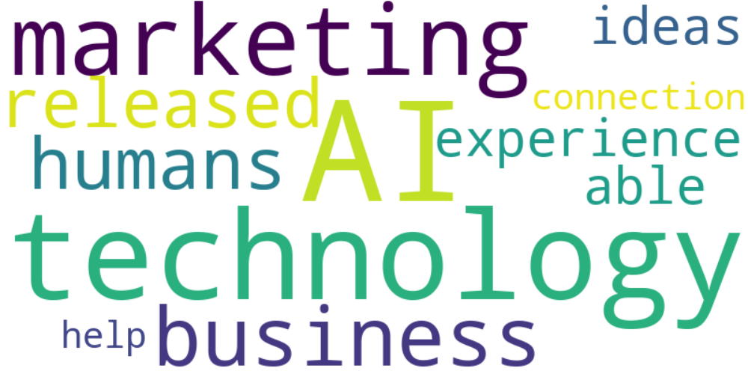

Top 10 words:

- AI: 10  
- technology: 8  
- marketing: 6  
- like: 5  
- business: 4  
- humans: 3  
- released: 3  
- experience: 3  
- able: 3  
- ideas: 3

### Wordcloud of summary

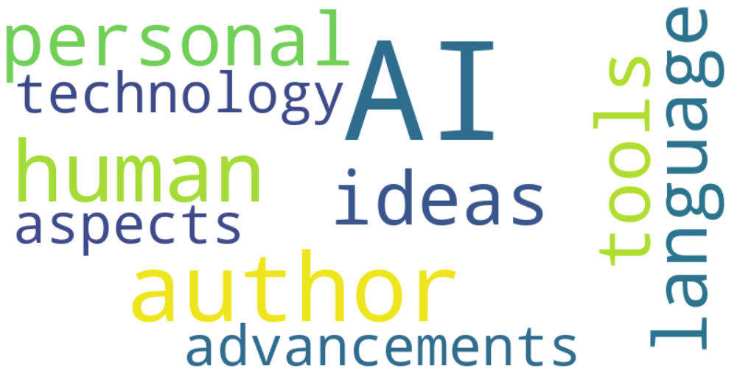

Top 10 words:

- AI: 14  
- author: 5  
- like: 4  
- human: 4  
- tools: 3  
- personal: 3  
- ideas: 3  
- language: 3  
- technology: 3  
- advancements: 3